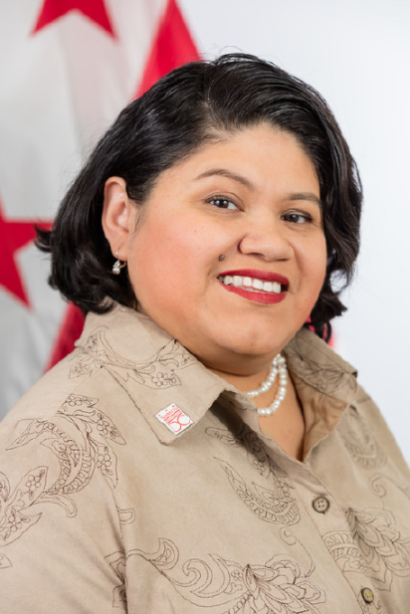
Jackie Reyes-Yanes serves as director of the Mayor’s Office on Latino Affairs (MOLA) and is responsible for advocating and making the Latino community an integral part of the District of Columbia. The mandate of the agency, which is part of the Executive Office of the Mayor, is to ensure that full range of health, education, employment, and social services are made available to Latino residents of the District of Columbia. Her experience spans more than nine years of commitment to the diverse Latino community in DC. In her previous role, she acted as the Latino Affairs and Community Outreach Director for former DC councilmember Jim Graham (D – Ward 1). While serving with Graham, Reyes-Yanes spearheaded initiatives to address the needs of Latino residents in the District. Several of her accomplishments include: organizing gang prevention events that successfully reduced street violence and crime, and helping secure financing to rebuild the Monseñor Romero Apartments in Mount Pleasant which were destroyed by a fire in 2008. Reyes-Yanes has deep roots in the community and a track record of success working in support of causes that help the Latino community. She is recognized throughout the District for her efforts to create a safe space for the immigrant community through strategic lobbying for immigration reform. Reyes-Yanes is a Ward 7 resident and Salvadorian activist. She made DC her home in 1990.

